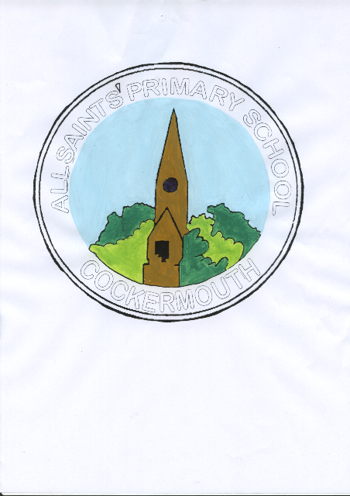

**Calling All Scientists, Engineers, Web developers, Statisticians, Mechanics, Nurses, Vets and Doctors!**

**All Saints’ CE Primary School**

**Needs YOU!**

We are hoping to create a really inspiring display and book about the different careers of parents and carers in our community with a STEM (Science, Technology, Engineering and Maths) based job.

You may have done a STEM related subject at school, college or university or you may have ended up in a related job completely by chance!

However you got there, we would love to hear about your journey and share it with all our children to inspire the Scientists, Programmers, Engineers, Teachers and Mathematicians of the future!

If you can help, please fill in the attached document and return it to school or find the electronic version on our website. <https://all-saints-ce-primary.secure-primarysite.net/science-1/>

Any pictures you can add would be hugely appreciated.

Many thanks,

Miss Dykes

Science Subject Leader

[ydykes@allsaints.cumbria.sch.uk](mailto:ydykes@allsaints.cumbria.sch.uk)