MUSIC: Just 3 notes • Invent simple patterns using rhythms and notes C-D-E. • Compose music, structuring short ideas into a bigger piece. • Notate, read, and follow a ‘score’. • Recognise and copy rhythms. Samba with Sérgio • Perform call-and-response rhythms by ear using word rhythms and transfer rhythms to instruments. • Perform vocal percussion as part of a group. • Move in time with the beat of music. • Talk about what has been learnt about Brazil and Carnival i.e. Samba batucada instruments and playing. Fly with the stars • Create rhythmic accompaniments based around arpeggios and crotchet, quaver durations.  QUESTFUL RE: Rules for Living The need for rules to live by is discussed and linked to the events of the Fall (Genesis 3), the rescue of the PEOPLE OF GOD followed by the gift of the 10 commandments (Exodus 19 and 20) and the impact of Jesus’ new command in the GOSPEL to love one another.  MODERN FOREIGN LANGUAGES – FRENCH: Show understanding of words & phrases. Appreciate stories and songs, poems & rhymes  Broaden vocabulary.  PSHE: Fairtrade – running a Fairtrade stall at the Christ Church Coffee morning. RSE: - Keeping Safe, Healthy Lifestyles and 1Decision programme covering: Touch, Relationships, Making Friends Online, Computer Safety, Grief and Feelings & Emotions  HOMEWORK: Children have reading homework every night / spellings, handwriting and times tables to learn on a weekly basis. Other areas of homework will be set e.g. Numeracy / Literacy. Research work for other curriculum subjects is sometimes set. We will try to keep to the following time table:  Monday – Spellings/Literacy Tuesday – Numeracy  Homework to be handed in the following week.  VISITS/ ENRICHMENTS Farm Visit. Fairtrade Stall at Christ Church coffee morning (July). Collective Worships by external visitors to our school. Sports Day. Park Day, Whole School Walk and Talent Show. Y3 Residential to St John’s in the Vale. | All Saints’ CE School  Y3 Curriculum Information  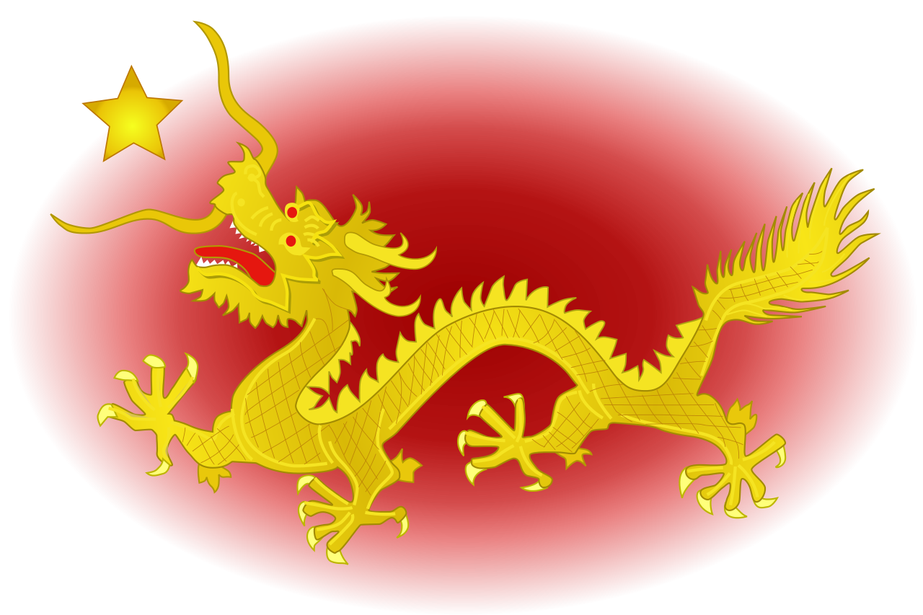  Summer Term  Theme – Shang Dynasty  Brazil & Rio  Miss Y S Dykes  ydykes@allsaints.cumbria.sch.uk
Year 3 Work for Summer Term (Brazil & Rio)  LITERACY STRATEGY: RIO,  Phonics – we will be following the No Nonsense Phonics to catch-up with any Phonics missing from Year 2.  Reading Use knowledge to read ‘exception’ words. Read range of fiction & non-fiction. Use dictionaries to check meaning. Prepare poems & plays to perform. Check own understanding of reading. Draw inferences to make predictions. Retrieve & record information from non-fiction books. Discuss reading with others.  Writing Use prefixes & suffixes in spelling. Use a dictionary to confirm spellings. Write simple dictated sentences. Use handwriting joins appropriately. Plan to write based on familiar forms. Rehearse sentences orally for writing. Use a varied rich vocabulary. Write non-chronological reports about our Topic Rio, Brazil, N America and Climate Zones. Create simple setting & plot. Assess effective of own and others’ writing  Grammar Use a range of connectives. Use a perfect tense (past, present, future). Use range of nouns & pronouns. Use time connectives. Introduce speech punctuation. Know Language clauses (a clause has a verb & subject and can be independent (simple sentence) or dependent (joined by a comma or connective).  Speaking & Listening Give structured descriptions. Children participate in conversation activities. Consider & evaluate different viewpoints.  MATHS – WHITE ROSE MATHS CURRICULUM  Number: Fractions Measurement: Time Geometry: Properties of Shape Measurement: Mass & Capacity  WARM UPS – include revisiting Place Value & Number, Fractions, Geometry, Mental Maths, Multiplication & Division, Measurement and Statistics.  SCIENCE: Helping plants grow well Plants provide food for us. Observe and measure plants. Water is taken through the roots. Measure the volume of water and height of plant accurately. Light is needed for healthy growth. Fair test. | Light and shadows: How shadows are formed. The shape of shadows. How shadows change over the course of a day: length and position. How the sun appears to move across the sky. The higher the sun the shorter the shadow. Earth spins on an axis.  D&T Food Technology – using seasonal food to create recipes. Follow a recipe; follow food safety & hygiene rules; chop using the bridge/claw safely; snip herbs with scissors (in a jug); use a citrus squeezer; season to taste; tidy away. South American cooking making Salsa – from Phunky Foods  COMPUTING: Computing Thinking: We Are Games Testers. Programming: Scratch.  GEOGRAPHY: Brazil & Rio Children will locate South America on a world map and be able to identify a range of its physical and human features. They will learn about the equator, time differences in South America and compare the UK with Brazil. We will follow the Christian Aid Lessons about the Favelas in Rio.  HISTORY: Shang Dynasty We will learn about the ancient Shang dynasty. Who the Ancient Shang people were, where and when they lived, using maps and atlases to locate Shang cities. The role of the king, the religious beliefs and rituals of the Shang people and how oracle bones were used in divination ceremonies. The children will also examine a range of Shang artefacts and draw conclusions about what they can teach us.  Please bring PE bag in and leave on peg for TUESDAYS.  PE: Rolling/ bowling Different speeds, games skills. Bouncing: bounce pass, dominant hands, and control. Throwing underarm, co-operative team games. Catching: variety of ways. Athletics Sports day.  ART: Natural Materials Inspired by the artists Frances Hatch and Anna Atkins using natural materials to experiment with collage and painting techniques, compare, discuss and improve work.

